CSE420
Samuel Marrujo
Professor Yu
Lab 12

Viewing
In this part of the lab, it was a modification of the original cube program. After some modifications to the program, and adding in the functions asked for, the result was the following reproduction of the figure. This was very similar to the previous part of the lab. Because of this change to the functions and the addition of the figure, I believe I was able to accomplish this task successfully, since there were no errors and the display window was changed. Here are my results for this program:

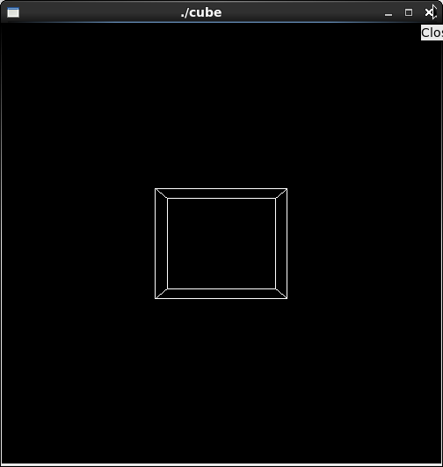

//cube.cpp
#include <GL/gl.h>
#include <GL/glu.h>
#include <GL/glut.h>

void init(void)
{
glClearColor (0.0, 0.0, 0.0, 0.0);
glShadeModel (GL_FLAT);
}

void display(void)
{
glClear (GL_COLOR_BUFFER_BIT);
glColor3f (1.0, 1.0, 1.0);
glLoadIdentity (); /* clear the matrix */
/* viewing transformation */
gluLookAt (0.0, 0.0, 5.0, 0.0, 0.0, 0.0, 0.0, 1.0, 0.0); //switched it back
glScalef (1.0, 1.5, 1.0); /* modeling transformation */
glutWireCube (1.0);
glFlush ();
}

void reshape (int w, int h)
{
glViewport (0, 0, (GLsizei) w, (GLsizei) h);
glMatrixMode (GL_PROJECTION);
glLoadIdentity ();
glFrustum (-1.0, 1.0, -1.0, 1.0, 1.5, 20.0);
glMatrixMode (GL_MODELVIEW);
}

int main(int argc, char** argv)
{
glutInit(&argc, argv);
glutInitDisplayMode (GLUT_SINGLE | GLUT_RGB);
glutInitWindowSize (500, 500);
glutInitWindowPosition (100, 100);
glutCreateWindow (argv[0]);
init ();
glutDisplayFunc(display);
glutReshapeFunc(reshape);
glutMainLoop();
return 0;
}

Rotation Animation

In this part of the lab, it was a modification of the original cube program. After some modifications to the program, and adding in the functions asked for, the result the following screenshot. Because of this change to the functions and the addition of the figure, I believe I was able to accomplish this task successfully, since there were no errors and the display window was changed. Here are my results for this program:

